**ICD 10 Implementation**

**&**

**Diagnosis At Service**



***Live Well San Diego***

**County of San Diego**

**Behavioral Health Services**

**TABLE OF CONTENTS**

|  |  |
| --- | --- |
|  |  |
| Table of Contents………………………………………………………………… | 1 |
| New ICD 10 Diagnosis Form.…………………………………………………… | 2 |
| Updating ICD 9 Diagnoses to ICD 10.………………………………………….. | 3 |
| Signatures…………………….………………………………...………………… | 6 |
| Staff Who Do Not Require a Co-Signature ………………………………….. | 6 |
| Staff Who Require a Co-Signature …………………………………………… | 7 |
| Staff Who Final Approve (or Co-Sign) Assessments For Others………….. | 9 |
| Support Staff Who Enter Information on Behalf of Others ………………… | 10 |
| Adding Signatures After Deletion…………………………………………….. | 13 |
| Diagnosis At Service (DAS)…………………………………………………… | 15 |
| Individual Progress Note Entry……… …………………..…………………… | 15 |
| Group Progress Note Entry………….………………………………………… | 19 |
| Individual Client Services Maintenance……………………………………… | 21 |
| Group Services Maintenance………………………………………………….. | 24 |
| Display Client Services..……….……………….……………………………… | 26 |

**New ICD 10 Diagnosis Form**

As of October 1, 2015, federal regulations require the use of ICD 10 diagnosis codes. As a result, **ALL** current ICD 9 codes will need to be ended before or on 9/30/15 and re-entered into the system as ICD 10 codes. To update the diagnosis codes to ICD 10, users can either enter a new standalone Diagnosis Form or complete it through a clinical assessment (BHA, DCSUM, and Psychiatric Assessment) with an embedded Diagnosis Form.

The new Diagnosis Form is below. Please note the new nonaxial format.

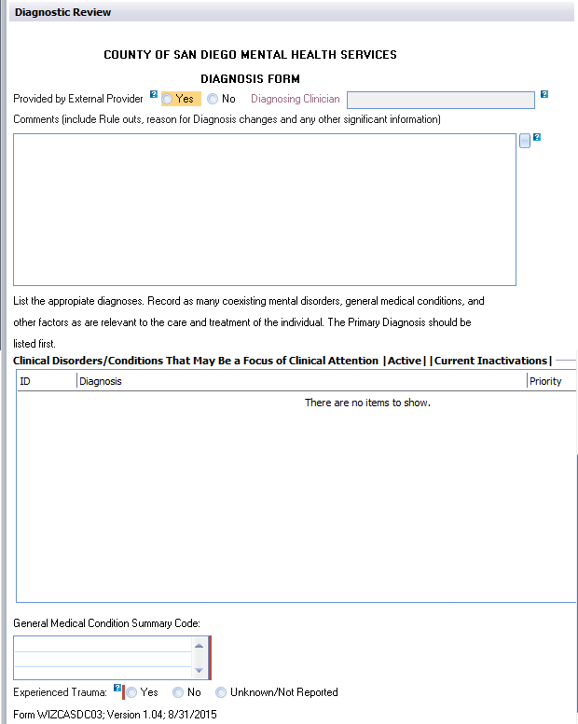

**Updating ICD 9 Diagnoses to ICD 10**

1. When a new Diagnosis Form is launched, the client’s existing diagnoses and existing comments will pre-populate onto the new Diagnosis Form.

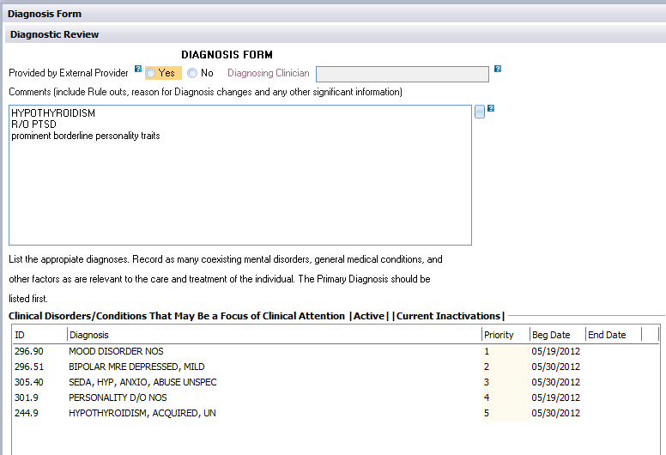

1. To end the ICD 9 diagnosis code, select the diagnosis, right click and select “Edit.”

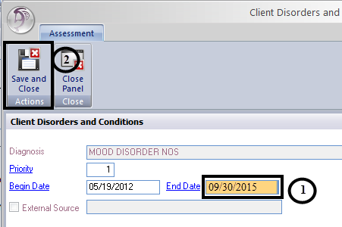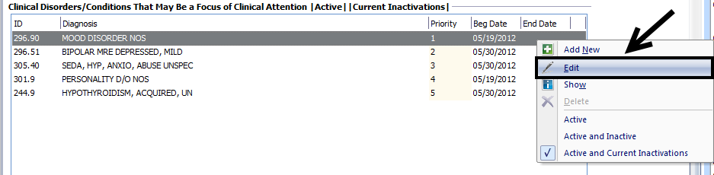

1. Enter the appropriate end date and select “Save and Close.”
2. These steps should be repeated for all active ICD 9 codes. A Diagnosis Form with an effective date of 10/1/15 or later cannot be final approved if it contains an active ICD 9 diagnosis.
3. Locate the appropriate ICD 10 diagnosis code (crosswalks are one tool, but should never replace use of diagnostic manuals. This is a good time to clean up the diagnoses that your client may have. If there are diagnoses that no longer apply to your client’s symptoms, end them no later than **9/30/15**.
4. To add a new ICD 10 diagnosis, right click in the “Clinical Disorders/Conditions” box and select, “Add New.”

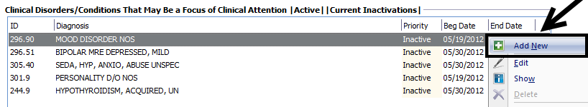

*Some tips for searching: Make sure the alpha is a CAPITAL letter.*

*Make sure to enter the period in the code.*

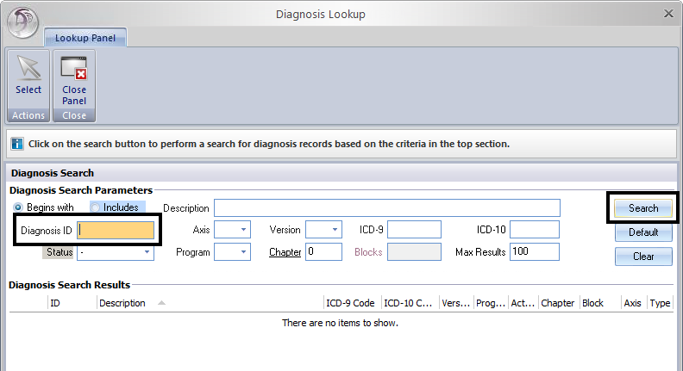

If you are having difficulty locating the correct diagnosis, try searching with the “Diagnosis ID” search field in the “Diagnosis Lookup” screen with the above criteria.

1. Enter the new ICD 10 diagnosis with 10/1/15 or later as the start date and select “Save and Close.”

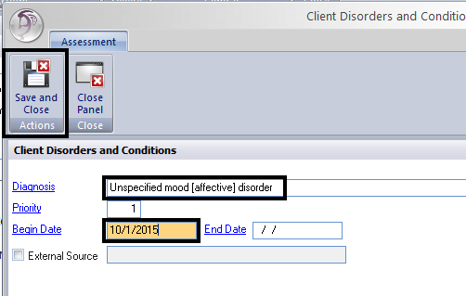

1. These steps should be repeated for applicable diagnoses entered for the client.

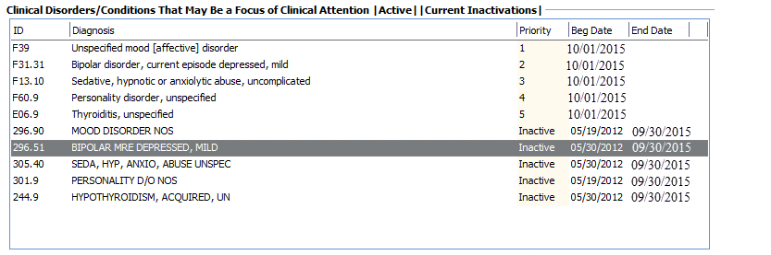

1. Make any adjustments, such as adding a new diagnosis, before completing the signature portion.

*****NOTE:*** *Z03.89 will replace V71.09 as No Diagnosis*

*R69 will replace 799.9 as Deferred*

MC900438271[1]

**Signatures**

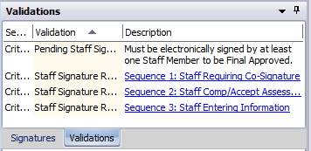

There are three credential restricted signature lines located in the “Validations” pane of the Diagnosis Form.

Your license type or credential will determine how you address each signature line.

**Staff Who Do Not Require a Co-Signature:**

1. Sequence 1 (Staff Requiring Co-Signature) - Left click and select “Delete.”

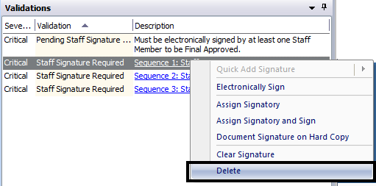

1. Sequence 2 (Staff Comp/Accept Assessment) – Left click and select “Electronically Sign.”

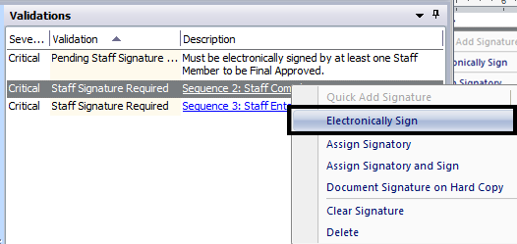

1. Enter your CCBH password when prompted.

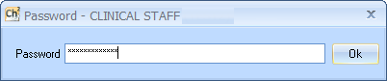

1. Sequence 3 (Staff Entering Information) – Left click and select “Delete.”

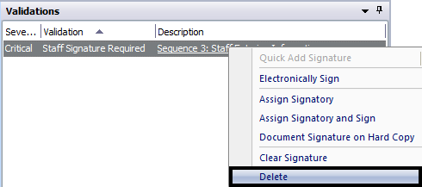

1. Select “Final Approve,” located at the top of the window.

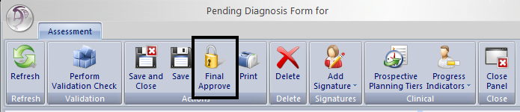

**Staff Who Require a Co-Signature:**

1. Sequence 1 (Staff Requiring Co-Signature) - Left click and select “Electronically Sign.”

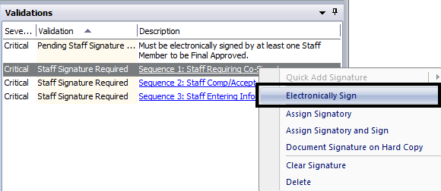

1. Enter your CCBH password when prompted.

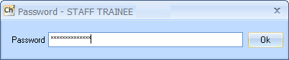

1. Sequence 2 (Staff Comp/Accept Assessment) – Left click and select “Assign Signatory.”

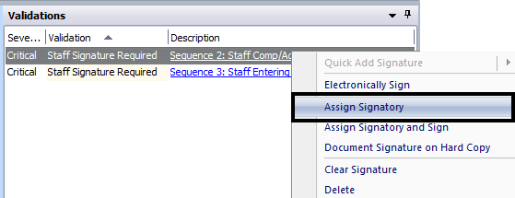

1. Find your supervisor by name or staff ID. Highlight their name and choose “Select” at the top.

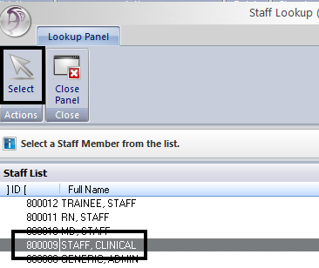

1. Sequence 3 (Staff Entering Information) – Left click and select “Delete.”

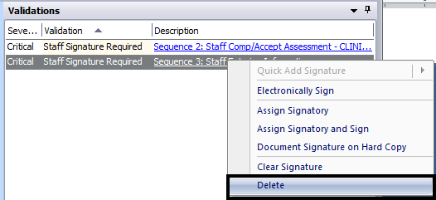

1. Click “Save and Close” located at the top of the window. After you click “Save and Close,” you return to the Clinician’s Homepage. The name of the client will display on the Notifications list on your Clinician’s Homepage and on the Homepage of the approved signer until the assessment is co-signed and final approved.

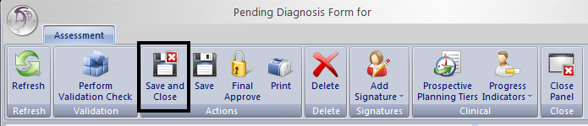

**Staff Who Final Approve (or Co-Sign) Assessments For Others:**

1. Find the client on your Notifications list on the Clinician’s Homepage.
2. Access the Diagnosis Form and review. The person for whom you are co-signing should have already completed Sequence 1 signature line and deleted Sequence 3.
3. Sequence 2 (Staff Comp/Accept Assessment) – Left click and select “Electronically Sign.”

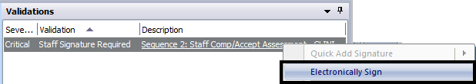

1. Enter your CCBH password when prompted.

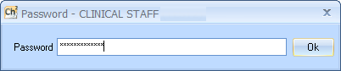

1. Click “Final Approve” located at the top of the window.



REMINDER: Co-signatures and final approval of assessments should be done as soon as possible.

**PLEASE REMEMBER:**

 **Passwords may NEVER be shared as this constitutes a**

**breach of security and HIPAA violation.**

**Support Staff Who Enter Information on Behalf of Others:**

Support staff entering information on behalf of others, from a hard copy, will address the signatures as they are listed on the hard copy.

**Sequence 1:**

**If the hard copy is signed by a staff that required a co-signature:**

1. Sequence 1 (Staff Requiring a Co-Signature) Left click and select, “Document Signature on Hard Copy.”

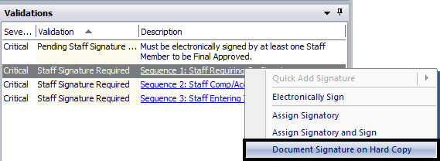

1. Enter the staff’s CCBH ID number. Make sure to adjust the date to match the hard copy. Select “OK.”

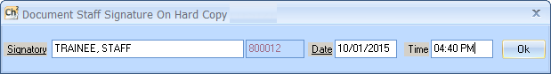

1. Enter your CCBH password.

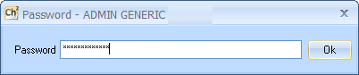

**If the hard copy is not signed by a staff that required a co-signature:**



1. Sequence 1 (Staff Requiring a Co-Signature) Left click and select, “Delete.”

**Sequence 2:**

1. Sequence 2 (Staff Comp/Accept Assessment) – Left click and select “Document Signature on Hard Copy.”

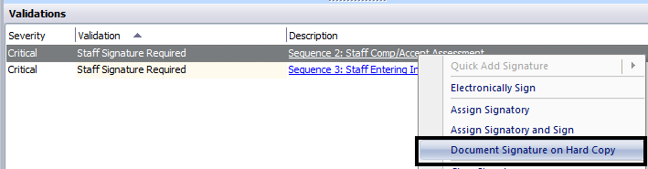

1. Enter the staff’s CCBH ID number. Make sure to adjust the date to match the hard copy. Select “OK.”

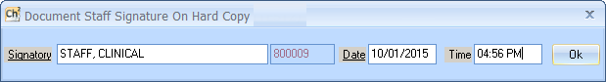

1. Enter your CCBH password.



**Sequence 3:**

1. Sequence 3 (Staff Entering Information) Left click and select “Electronically Sign.”

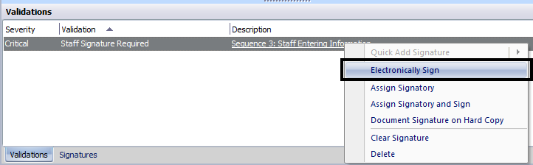

1. Enter your CCBH password.



1. Select “Final Approve” located at the top of the window.



MC900438271[1]

**Adding Signatures After Deletion**

If you happen to delete the wrong signature line, it is possible to add the signature line back in.

1. Select “Add Signature” from the top ribbon. A drop down menu will appear. Select “Add Staff Signature.”

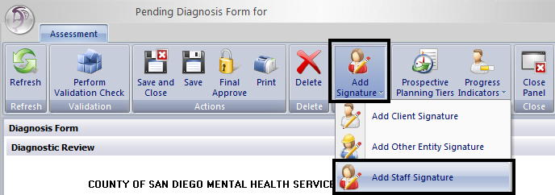

1. Select the “Signature Heading” link to display a table with the choices available. Select the signature heading which needs to be added back in and choose “Select.” Be sure to only select one of the three standard options for a Diagnosis Form.

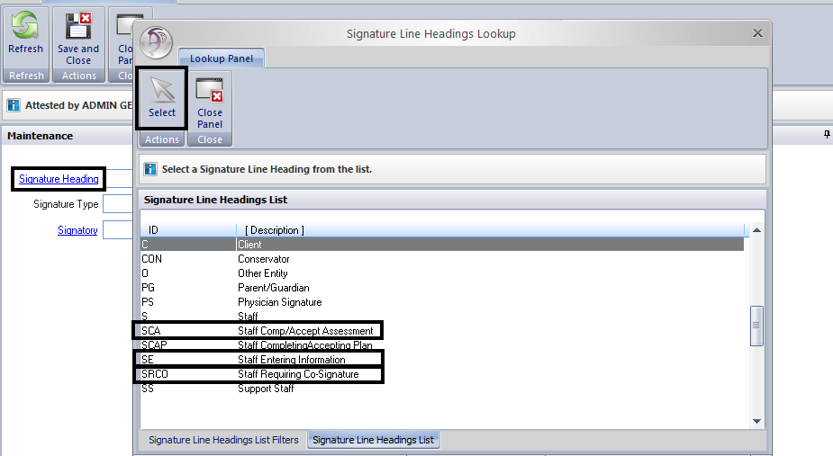

1. Select which type of signature to provide from the drop down.

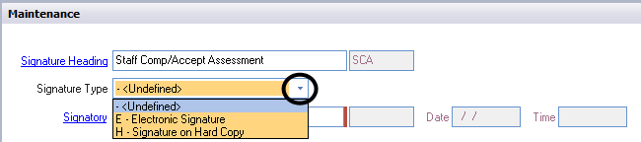

1. Enter the staff’s CCBH ID number or search for the staff by clicking on the “Signatory” link. Make sure to adjust the date to match the hard copy. Select “Save and Close.”

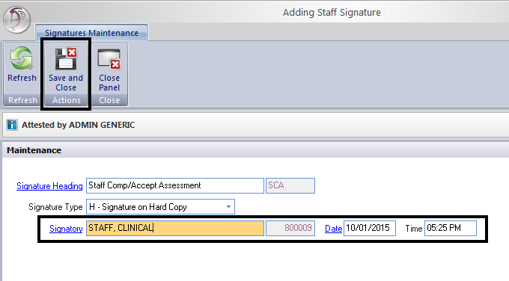

1. Enter your CCBH password.



MC900438271[1]

**Diagnosis At Service (DAS)**

Diagnosis At Service will require anyone claiming for a service to show the diagnoses that are the focus of each service. CCBH offers a new functionality of being able to link a client’s diagnoses within the service entry screens. Selecting the Diagnosis At Service (DAS) will be required for all services claimed through progress notes and for services **entered** manually on or after Oct. 1, 2015.

Users will be able to link the diagnosis to the service in the following screens: Individual Progress Note Entry, Group Progress Note Entry, Individual Client Services Maintenance, and Group Services Maintenance.



**NOTE:** When it is not within the scope of a staff person (admin or non-licensed/register/waivered staff) to make a diagnosis, making no selection of a specific diagnosis will allow all diagnoses to attach to the claim and appear on the printed progress note.

**Individual Progress Note Entry**

The Individual Progress Note Entry will have a new “Diagnoses” button appear after the Unit and Subunit are entered. However, this button should not be utilized until the server, service code, and service indicators are in place.

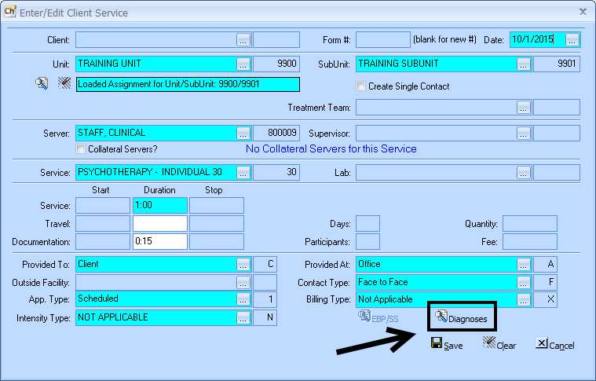

When you click on the button, a new screen will display all of the client’s active diagnoses on the date of service corresponding with that progress note. To add an additional diagnosis that is not listed, a new diagnosis assessment must be entered and final approved. To enter a new Diagnosis Form, users are able to “Save” their progress note, enter the assessment, and then return to the saved progress note. The progress note that was started does not need to be deleted. CCBH will recognize the update.

In this screen, you can add active diagnoses, delete diagnoses that were not the focus of treatment, and reprioritize diagnoses in the priority in which they were treated.

If there is diagnosis that will not be a focus of treatment, you may highlight the diagnosis and select the “Delete” button. Deleting a diagnosis on this screen only removes it from the service. It does not delete it from the client’s chart.

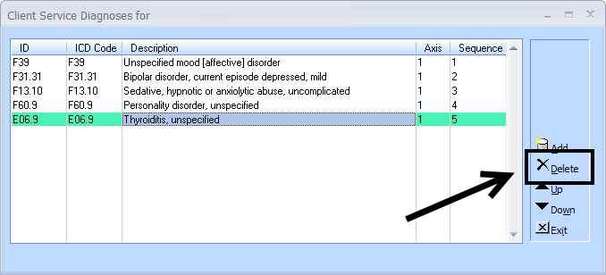

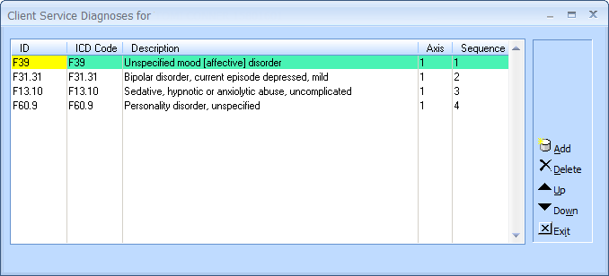

To re-add in a diagnosis that was deleted, select “Add.”

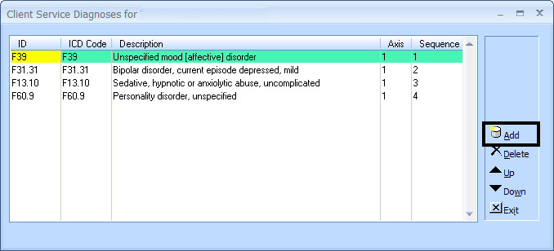

All diagnoses that were active on the date of service, and are not currently linked to the service will display. Check the box of the diagnosis you wish to add, and then select “Add.”

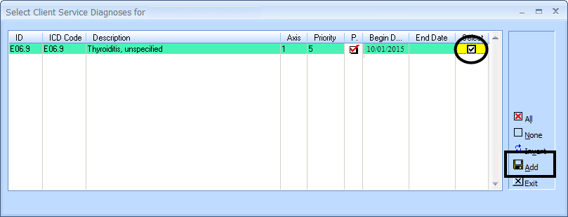

Reprioritize the diagnoses being treated by selecting a diagnosis and using the “Up” and “Down” buttons. The diagnosis you are treating should be first in the sequence.

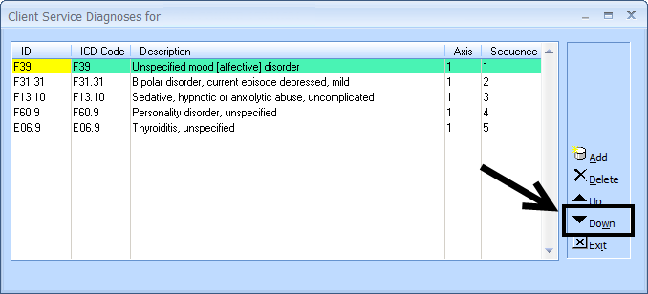

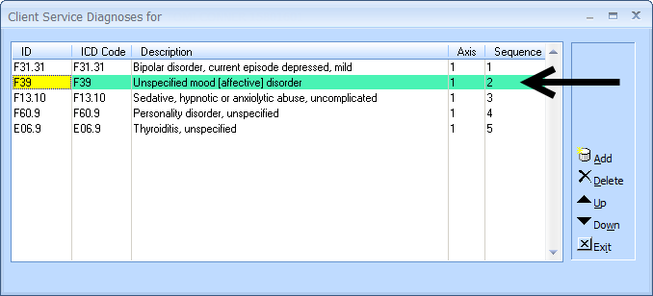

When satisfied with the priority order of the diagnoses, select “Exit.”

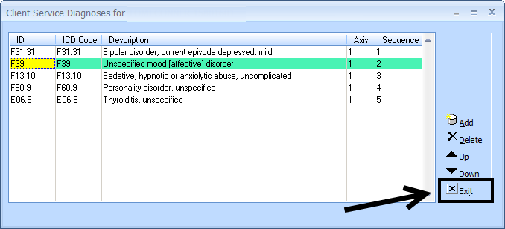

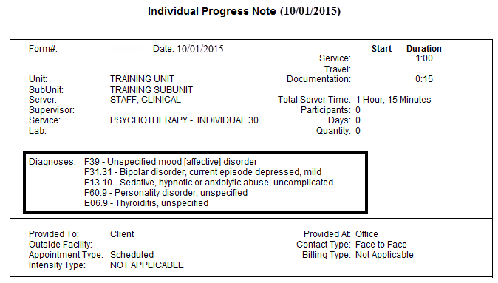

Proceed with final approving the progress note as normal. The diagnoses are now linked to the service and will display when the progress note is printed, as well as in “Display Client Services.”

**Group Progress Note Entry**

The Group Progress Note Entry will have a new “Diagnoses” button appear after the Unit and Subunit are entered. However, this button should not be utilized until the server, service code, and service indicators are in place.

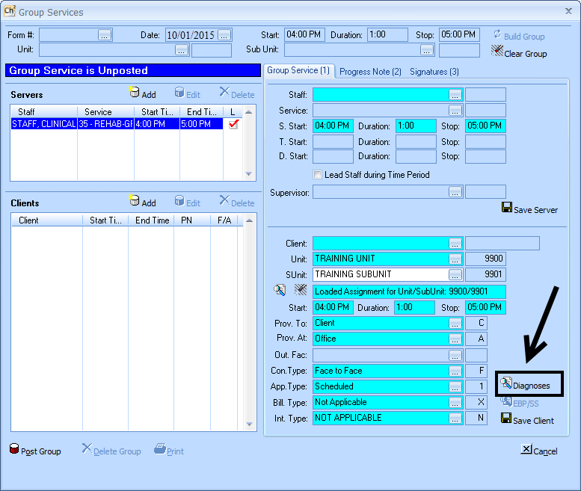

This screen will function the same as the “Diagnoses” button on the Individual Progress Note Entry screen. If the screen comes up with no diagnoses, and you are sure there is a final approved Diagnosis Form to cover the date of service, utilize the “Add” button.

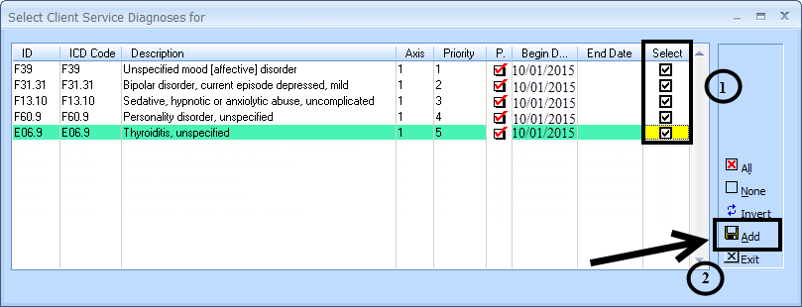

Select the diagnoses you wish to be added to the service by checking the corresponding box(es), and selecting “Add.”

Then proceed with reprioritizing the diagnoses by selecting the diagnosis and utilizing the “Up” and “Down” buttons. The diagnosis you are treating should be first in the sequence. When complete, select “Exit.”

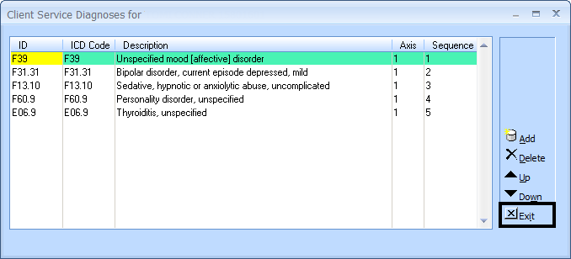

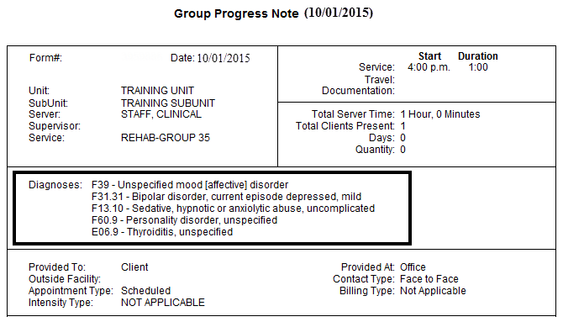

Complete the remainder of the Group Progress Note and post/final approve as usual. The diagnoses are now linked to the service and will display when the progress note is printed, as well as in “Display Client Services.” You will need to repeat the process for each client in the group.

**Individual Client Services Maintenance**

Support staff will also need to enter DAS. Most of the time support staff who enter services in the external view will not have to use the diagnoses button. However, if the services you are entering have a diagnosis preference (entered by the clinician on the Service Entry Request), you will select “Diagnoses.” If no instructions are given, support staff should not determine it on their own. All diagnoses should be added, and left in the order they populate in.

The Individual Client Services Maintenance screen will have a new “Diagnoses” button appear after the Unit and Subunit are entered. However, this button should not be utilized until the server, service code, and service indicators are in place.

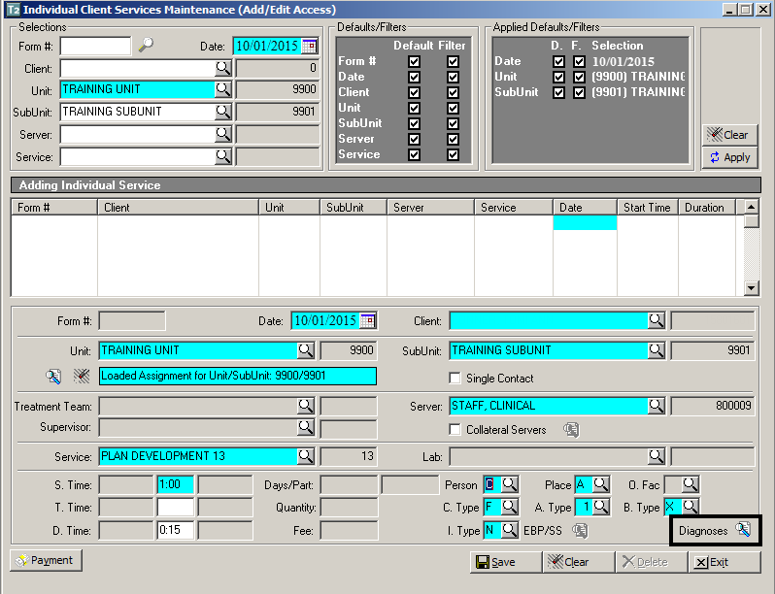

If support staff are asked to remove a diagnosis, select the diagnosis you wish to delete and select “Delete.” Deleting a diagnosis on this screen only removes it from the service. It does not delete it from the client’s chart.

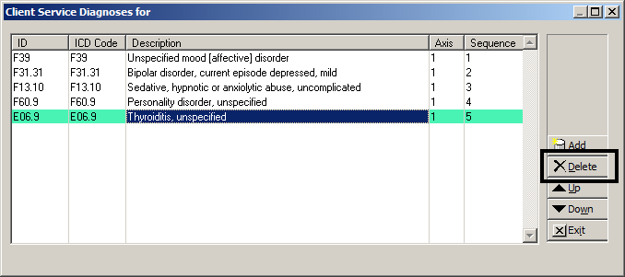

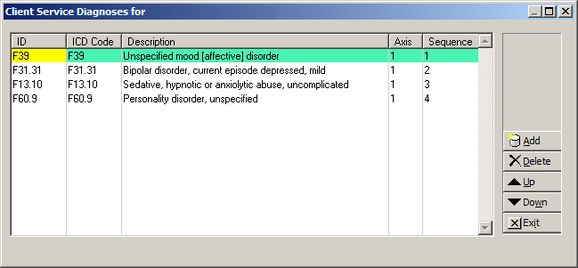

To re-add in a diagnosis that was deleted, select “Add.”

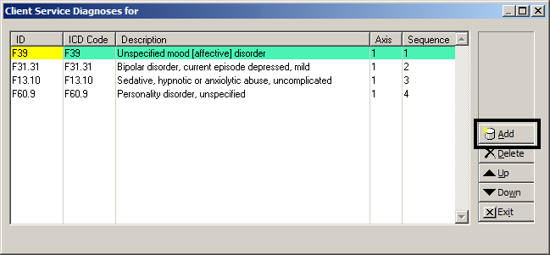

All diagnoses that were active on the date of service and are not currently linked to the service will display. Check the box of the diagnosis you wish to add, and then select “Add.”

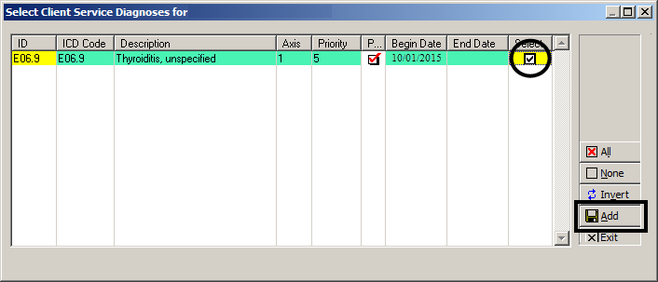

Reprioritize the diagnoses being treated by selecting the diagnosis and using the “Up” and “Down” buttons. When finished, the screen should match the hard copy of the Service Entry Request Form.

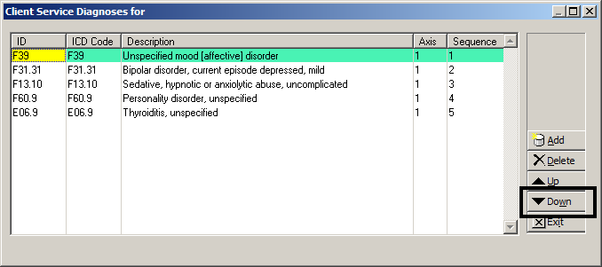

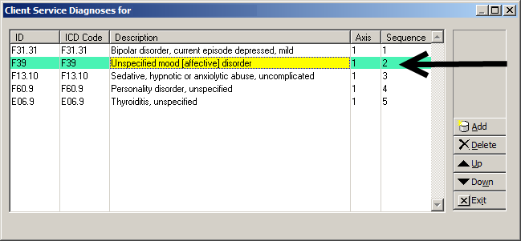

When satisfied with the priority order of the diagnoses, select “Exit.”

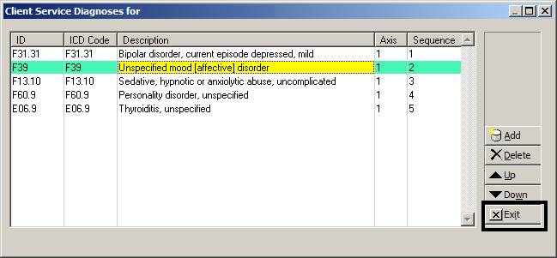

Proceed with saving the service as usual. The diagnoses are now linked to the service and will display in “Display Client Services.” If you are entering several claims on this one form, you will need to repeat the process for each entry.

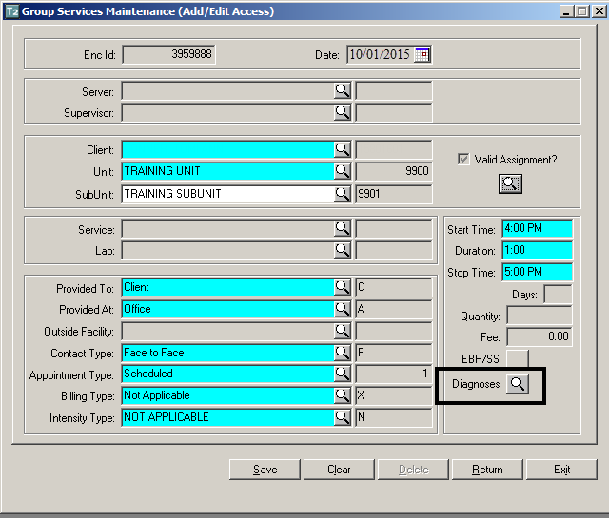**Group Services Maintenance**

The Group Service Entry screen will have a new “Diagnoses” button appear after the Unit and Subunit are entered.

However, this button should not be utilized until the server, service code, and service indicators are in place.

This screen will function the same as the “Diagnoses” button on the Individual Service Entry screen. If the screen comes up with no diagnoses, and you are sure there is a final approved Diagnosis Form to cover the date of service, utilize the “Add” button.

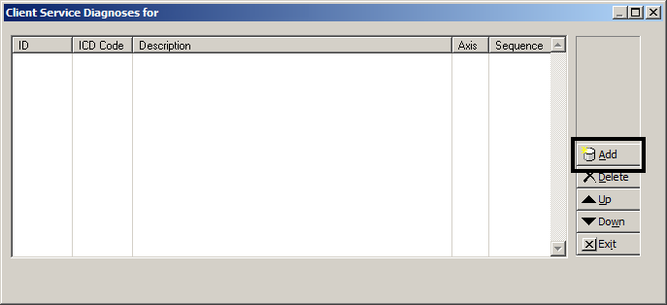

Unless otherwise specified by the clinical staff, support staff will select “All” (which will check all the boxes) and then “Add.”

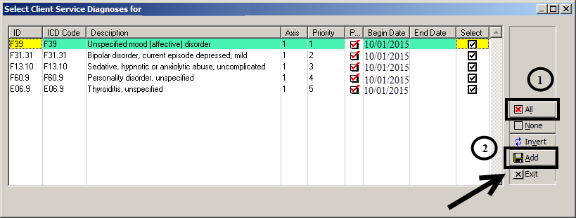

If necessary, proceed with reprioritizing the diagnoses by selecting the diagnosis and utilizing the “Up” and “Down” buttons. When complete, select “Exit.”

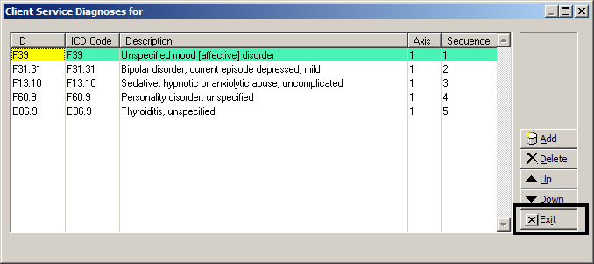

Complete the remainder of the group service and post as normal. The diagnoses are now linked to the service and will display in “Display Client Services.” You will need to repeat the process for each client in the group.

**Display Client Services**

Display Client Services will display diagnoses that are the focus of the service attached to the claim. Diagnoses will display in the order they were selected.

Locate the desired client and service in Display Client Services.

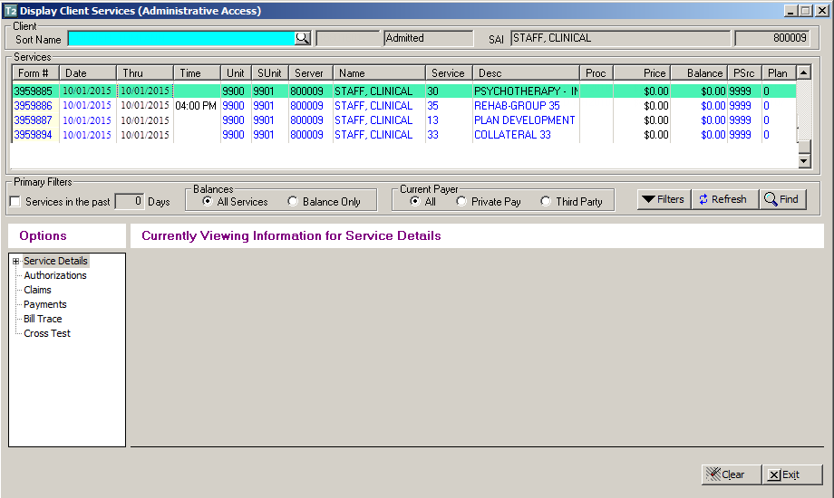

Select the plus sign next to “Service Details” and then select “Diagnosis Detail.” The diagnoses used for that service will display in the order they were sequenced.

