ACT/FACT EBP Monthly Bundled Rate Explanation Guide
The following service activities are included as part of the ACT/FACT EBP Medi-Cal Benefit, as defined in California’s Medicaid State Plan:
- Assessment
- Crisis Intervention
- Employment and Education Support Services
- Medication Support Services
- Peer Support Services
- Psychosocial Rehabilitation
- Referral and Linkages
- Therapy
- Treatment Planning
Prior Authorization
Prior authorization is required for ACT/FACT. The ACT/FACT team should submit a prior authorization request to their BHP following clinical determination that the member is appropriate for ACT/FACT services.
- Upon referral to an ACT or FACT program, SPOA will also notify Optum UM Unit of the referral for the purpose of providing an initial ACT/FACT BHP Referral Authorization.
  - Program must open client to the program either in Requested Status or Enrolled Status within two (2) business days of receipt of SPOA referral.
  - Optum will enter the initial ACT/FACT BHP Referral Authorization which will cover the first 21 days of client enrollment.
    - This allows program to engage clients in services and complete intake and assessment process.
    - Services provided during this initial authorization period are able to be included in the monthly bundled rate.
- Programs should run the COSD Authorizations Report daily to verify that a valid authorization has been entered for referred client(s) to minimize risks of service errors for missing authorizations or recoupment of services due to missing authorizations.
- Programs will be required to submit the Prior Authorization request to Optum via Secure Fax, using the BHS approved ACT/FACT Authorization Request form by Day 14 (calendar days) from the date of receiving the SPOA referral.
  - Programs should ensure that client meets eligibility criteria for ACT/FACT services and submit required clinical documentation.
  - Authorization determination will be faxed back to the program within 5 business days of receipt of request.
  - Programs can run the COSD Authorizations Report (My Office) to verify the authorization in SmartCare.
  - The ACT/FACT Authorization covers all ACT/FACT services provided to the client for 6 months.

Monthly Bundled Rates:
- Full monthly rate. For Medi-Cal members that receive at least six contacts on six different days in a month, of which at least four are delivered face-to-face (in-person) to the member. Other contacts may be with a collateral (i.e., family member and/or significant support person) to support the member’s recovery. If there are two or more contacts on a day, at least one of which is with the member and one of which is with a collateral, it may be counted as two separate days.
- Partial monthly rate. For Medi-Cal members that receive at least four contacts on four different days in a month, of which at least three are delivered face-to-face (in-person) to the member. Other contacts may be with a collateral (i.e., family member and/or significant support person) to support the member’s recovery. If there are two or more contacts on a day, at least one of which is with the member and one of which is with a collateral, it may be counted as two separate days.
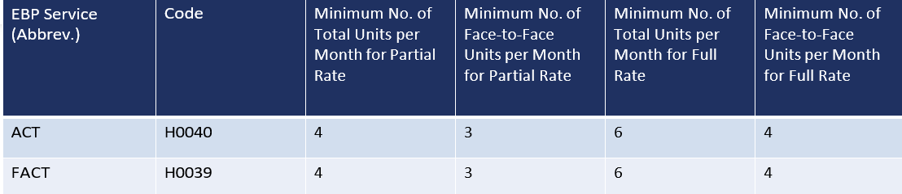

Requirements for claiming monthly bundled rates:
- Contact is defined as an encounter of at least 15 minutes in duration. Only one contact per day may be counted for payment purposes.
- Face-to-Face is defined as in-person with the client.
- For the BHP to claim the full monthly bundled rate for ACT/FACT, the member must receive a minimum of 6 encounters, and at least four of these encounters must be conducted face-to-face with the member.
- To claim the partial monthly bundled rate for ACT/FACT, the member must receive a minimum of 4 encounters, and at least three of these encounters must be conducted face-to-face with the member.
- Additional contacts with the member and/or with a collateral may be conducted via telehealth.
- If a member receives 12 or more ACT/FACT team contacts in a month, the BHP may claim for appropriate, unbundled Medi-Cal covered outpatient behavioral health services in addition to the monthly bundled rate.
  - Unbundled Medi-Cal-covered outpatient behavioral health services delivered by the ACT team can only be claimed after the member reaches 12 contacts in a month.
    - Example: client receives 15 contacts in a month; program can bill the appropriate bundled rate for contacts 1-12 and claim the unbundled rate for the additional individual rendered services (13-15).
- If a member receives fewer ACT/FACT team contacts than the minimum required for either the full or partial monthly bundled rate, the BHP may claim for appropriate unbundled Medi-Cal-covered services.
- While ACT/FACT teams must deliver the minimum contacts required for the BHP to claim either the full or partial monthly bundled rate, ACT teams are expected to provide as many contacts as needed to support a member’s recovery.

ACT/FACT in Residential Treatment Settings or Inpatient Settings
- Members who are in inpatient hospital or residential treatment settings may continue to receive ACT/FACT services from their ACT/FACT team.
  - Inpatient hospital settings include general acute care hospitals, acute care hospitals and psychiatric health facilities.
  - Payment is not available for ACT/FACT delivered to members while they reside in inpatient settings that are Institutions for Mental Diseases (IMDs), unless the IMD is participating in the BH-Connect IMD FFP Waiver.
    - Client stay must meet the IMD FFP waiver eligibility of 60 days or less in order for ACT/FACT services to be claimed.
    - Participating IMD settings: SDCPH, Sharp Mesa Vista, Alvarado Parkway Institute.
- BHPs may claim the full ACT/FACT rate during the month of a member’s admission or discharge to the inpatient or residential treatment setting.
  - Services must meet all requirements for the full monthly rate
  - At least 3 of the 6 required contacts must be delivered before admission or after discharge from the inpatient or residential setting.
- If the member is in the inpatient or residential treatment setting for the entirety of a month, BHPs may only claim the partial rate.
  - Services must meet all requirements for the partial rate
ACT/FACT in Correctional Facilities or Jail Settings
- The primary Medi-Cal services available to individuals while incarcerated are the targeted pre-release services authorized under the CalAIM Justice-Involved Initiative (which can be provided in the 90 days prior to release). These include (but are not limited to) reentry care management services (TCM/ICC) and behavioral health clinical consultation services. Through these pre-release services, an individual could be assessed and linked to an ACT or FACT team for post-release care, but they could not receive ACT or FACT services while in jail or prison.
References:
BHIN-25-009-Coverage-of-BH-CONNECT-Evidence-Based-Practices.pdf
EBP Policy Guide_ _5.1.25
Authorization for Services Process in SmartCare

