Group Documentation Tip Sheet- Client’s from Multiple Programs

Managing Groups
- When creating a group, the group may only be related to one program. If your facility has more that one program, you must select one of them to be the “host” of the group. You may decide to choose one of your programs to host all of the groups or you may choose the program which most of the participants will belong to to be the host.
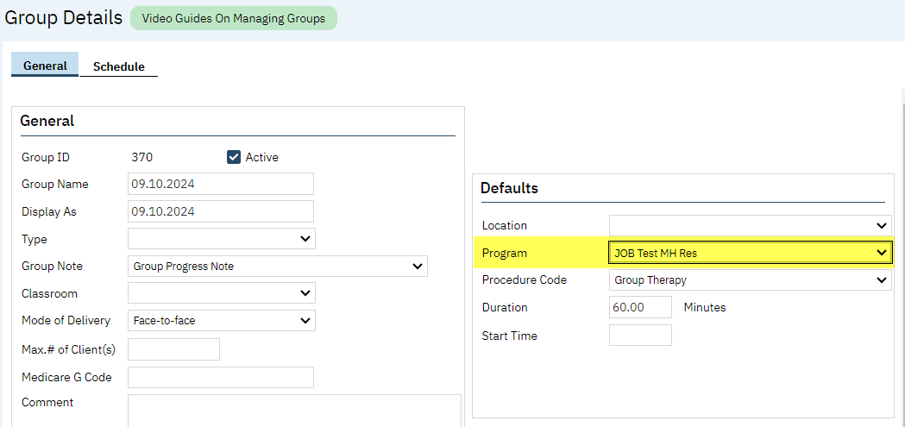
- When adding clients, it is OK to add clients from Programs different from the “host” program. Clients may be added when setting the Group up or when writing the note.
- After clicking “Add Clients…”
  - You may choose the Program you want to add clients from
  - Click Broad Search
  - See the list of clients currently open to that Program
  - Click Select to add the chosen client and keep adding clients
  - Click Select & Close to add the chosen client and close
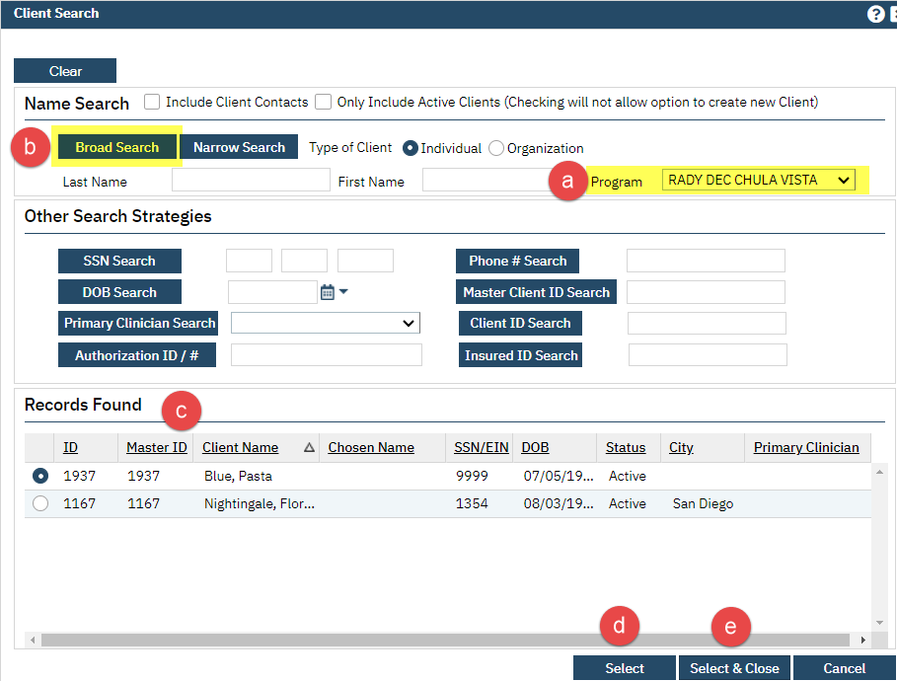

Note Writing
- It is always a good idea to make sure the clients all have Diagnosis Documents and Problems that are dated on or before the date the service was provided. If either of these are dated after the service date, they will not pull into the note.
- If the group contains clients that are not enrolled in the “host” program, the Service Information for each of these clients will need to be updated in order to make the Diagnoses and Problems appear from the programs they are enrolled in.
  - In the Group Service Detail screen, select the client whose Service Information needs to be updated to have the correct Program
  - In the Program dropdown, choose the program the client is enrolled which has entered their Diagnosis Document and Problems
  - Click Save
  - Go to the Billing Diagnosis tab to verify the diagnosis is displaying properly
